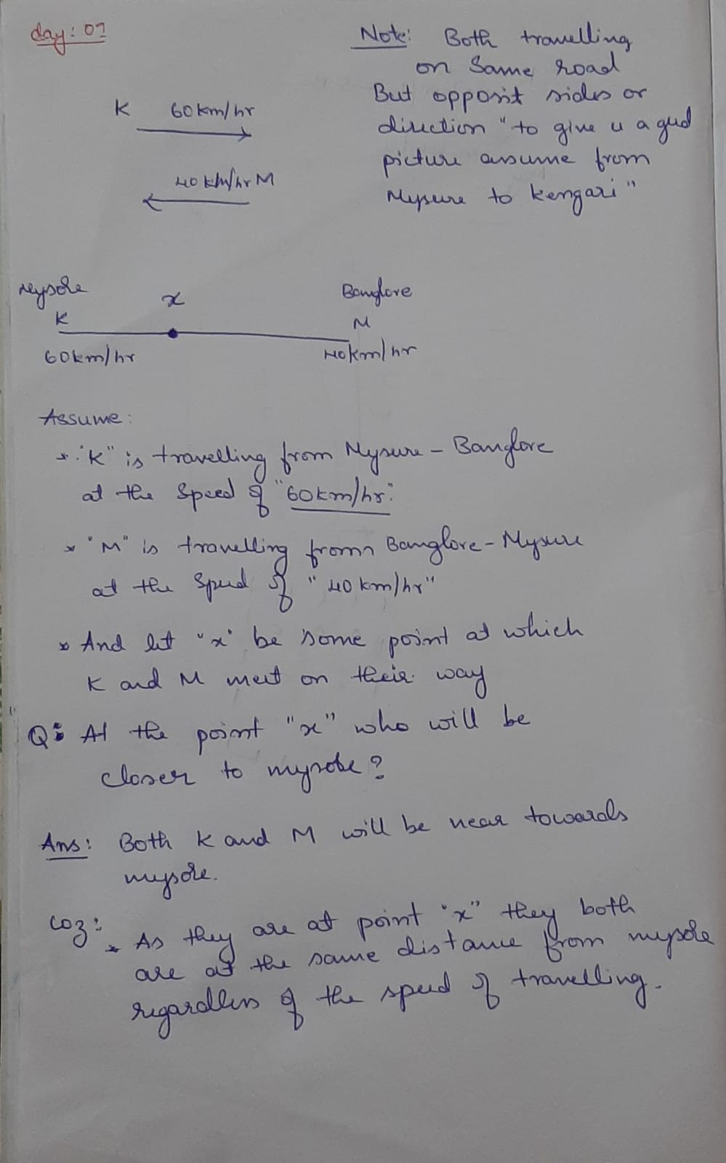

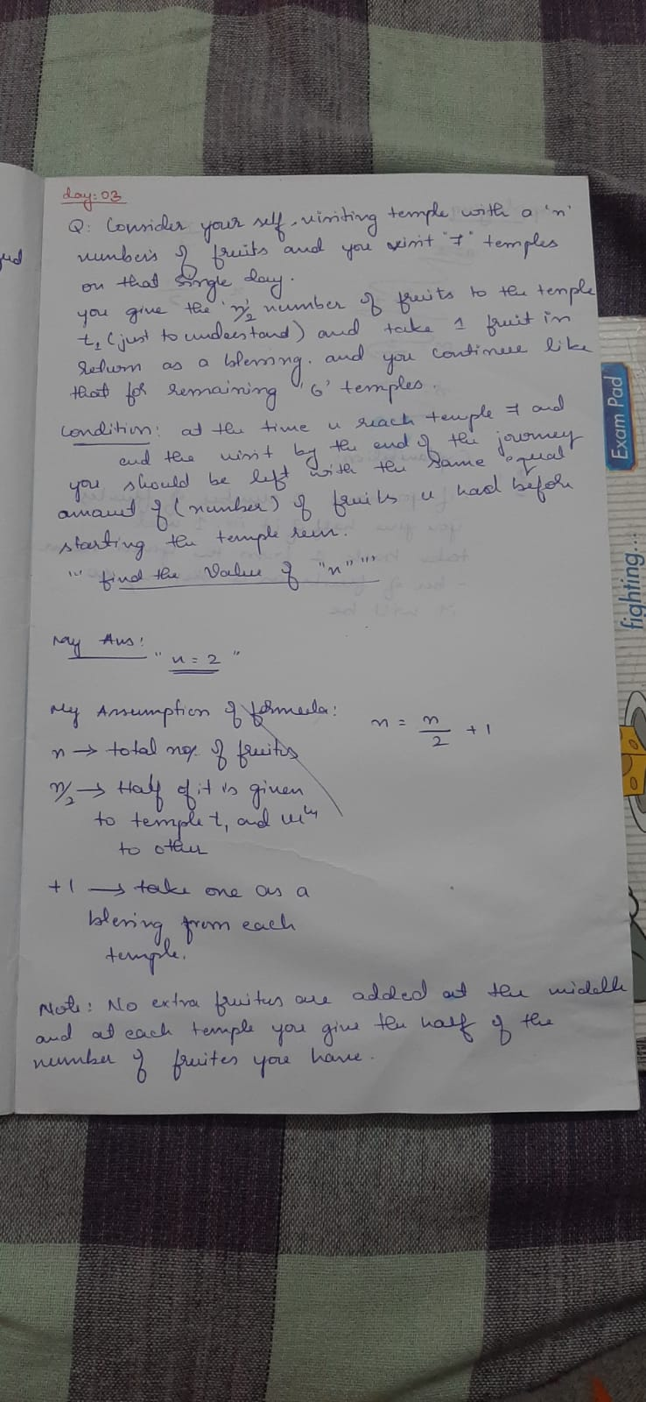

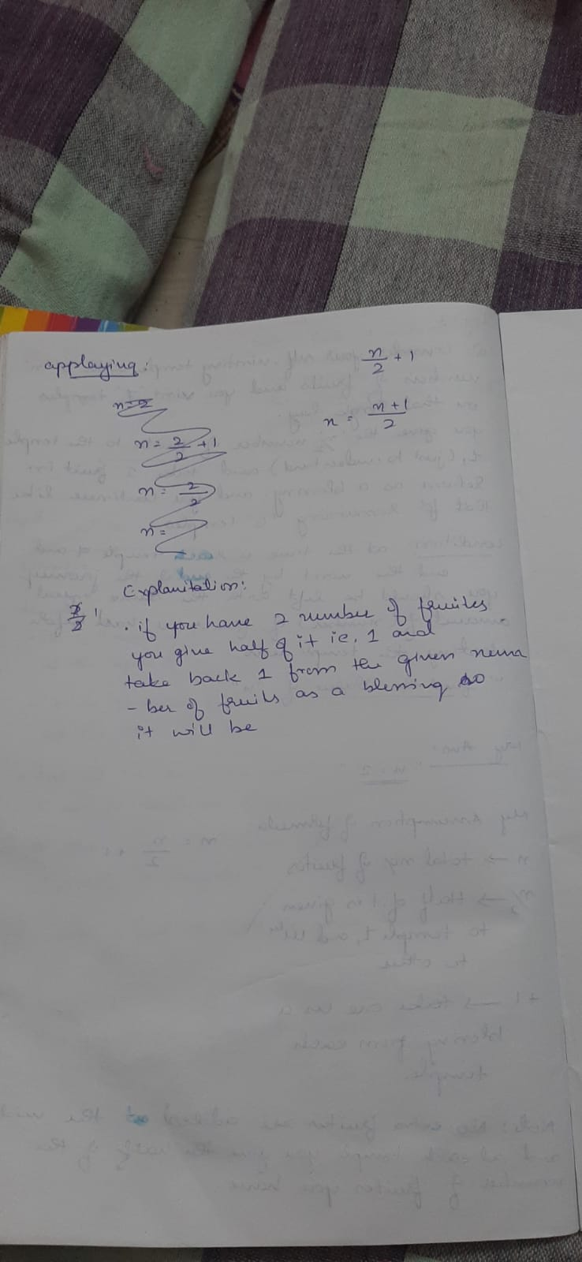

**Que:03**

1000 bottle of wine and 10 ppl to find out which one of the bottles is poisoned, by making 10 ppl (prisoner’s) drinking the wine. Condition the poison used takes 1hr in order to show any kinde of reason, but there is a party in an hr…… Dua!

Find the pattern to find the poisoned wine braille…